**How to Add a Project Repository to Your PEA Repository**

As part of the Program Exit Assessment, you will need to copy some of your projects to your PEA Repository. Unfortunately, git does not allow repositories of repositories so we will have to use ‘subtrees’.

A subtree makes a copy of a repository and lets you put the copy under a different repository. There are a few steps involved in doing this and, unfortunately, they are done using the git command line. The example below will provide the steps as done in the git bash shell. If you have installed a different tool, the steps to change directory might be a little different. Git bash uses a Linux type command line, so the operating system commands are based on that.

You will be repeating this process multiple times over the three years of the program. Each time you want to add a repository to the PEA repository it is added as a subtree so the process will be similar. Your teachers in various courses will remind you to do this when it needs to be done.

**Step 1. Download a Copy of Your PEA Repository**

The first thing you need to do is to download a copy of your PEA repository to your local hard drive. This can be done using GitHub Desktop, Git Lens (in VSCode) or other ways. To do it from the command line, change to the local folder you want to clone the repository to and issue the command:



Where “<<git-path>>” is the path to your repository; “<<yyyy>>-program-exit-assessment-<<your-git-username>>” is replaced with the name of the git repository and “LocalFolderName” is replaced with the folder you want to create at the current location on your local drive. For example, to download my repository I would issue the following:



You may be prompted to enter your git username and password when you issue this command. Once you enter the command, git will make a copy of your current PEA repository and put it in the location you specified. You should receive the following messages when you clone:

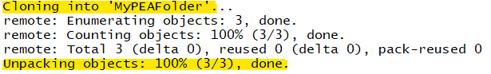

**Step 2. Change to Your PEA Repository**

To complete the rest of these steps you need to be in your local PEA repository folder. Do this using a simple cd command. For me that would be:



**Step 3. Remotely Add Personal Project Alias**

Now you need to add a reference to the project that you want to copy into your PEA folder. To do this, you remotely add the project you want to include to the current location. This will not actually copy the information, but will link your personal project as a part of the PEA project. This tell git that the repository you want to add is connected to your PEA repository, but does not actually copy or attach the repository in any way (that is the next step). To do this use the command:



Where <<name-of-repository-to-add>> is the name of your personal repository you wish to add to your PEA repository (for the example it is amcdonald_H10L05) and <<your-git-username>> is your username of the path to your repository. For me the command would be:



IMPORTANT: You MUST be in the local copy of your PEA repository when issuing this command. The response from this command should be something like this:

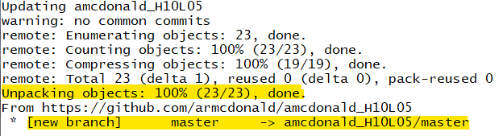

**Step 4. Add Personal Project as a Subtree to the PEA Repository**

Now that you have the reference created, you can add it as a subtree to your PEA repository using the command:



Where <<local-folder-name>> is the name you want to call the copy in your PEA repository; you should use the same name as the repository in almost every case. <<remotely-added-reference>> is the name you created in the previous step when you created the link. The <<branch-name>> at the end indicates the branch that you want to add it to in your PEA repository; in the example this is master. Branches will be explained more in subsequent courses. This will create a folder in the current location on your local disk with the specified name that contains the content that you wish to add to your PEA repository. If you look at the folder in file manager, the new folder should be there:

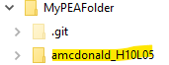

In my continuing example, I would enter:



The message returned should be something like:

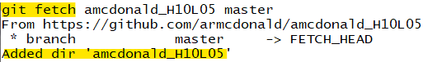

**Step 5. Push the Subtree Back to git**

The final step is to push your PEA repository back to the remote repository so that it syncs up with the online version of your repository. To do this issue the command:



This command tells git to take the current folder and push that information to the remote git in the <<branchname>> branch. You should receive a message similar to this one:

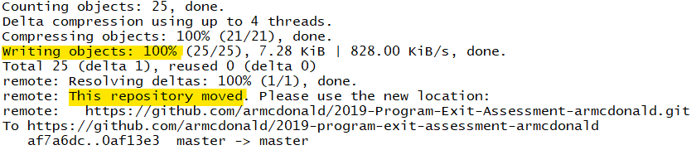

**Step 6. Check to Make Sure Subtree Successfully Added**

After that command successfully completes go to github.com to your PEA repository and make sure that the repository was successfully copied.

